Question 1- )

Yes ,My browser is running. My HTTP is version 1.1

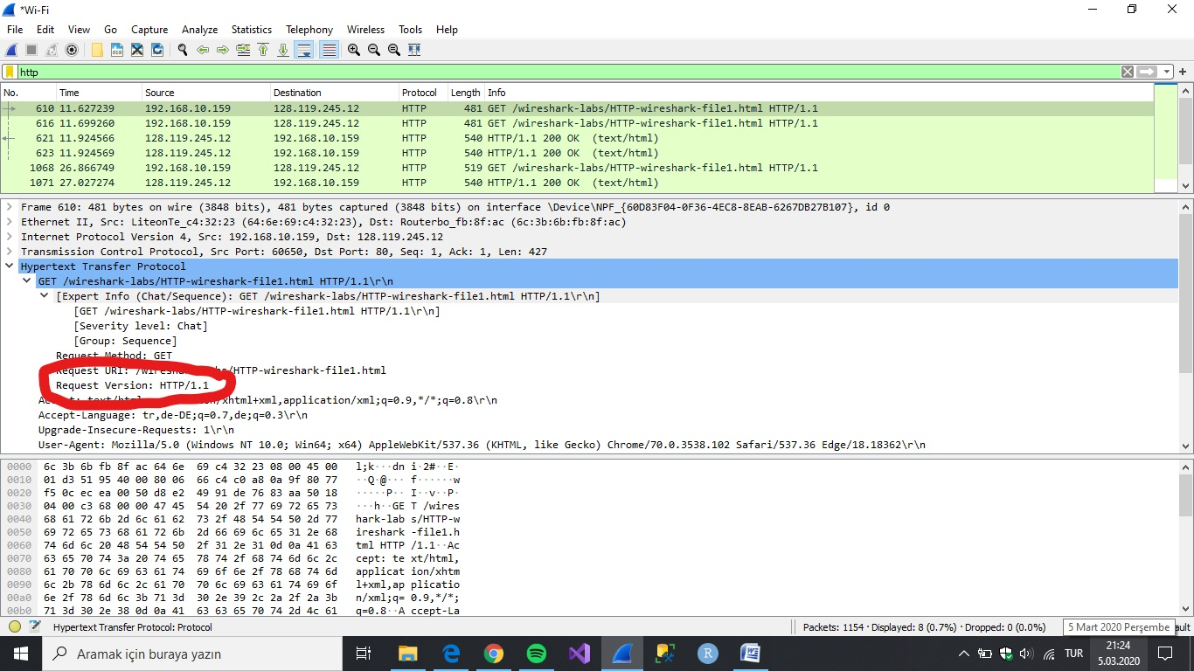

Question 2 - )

My browser shows tr, de – DE.

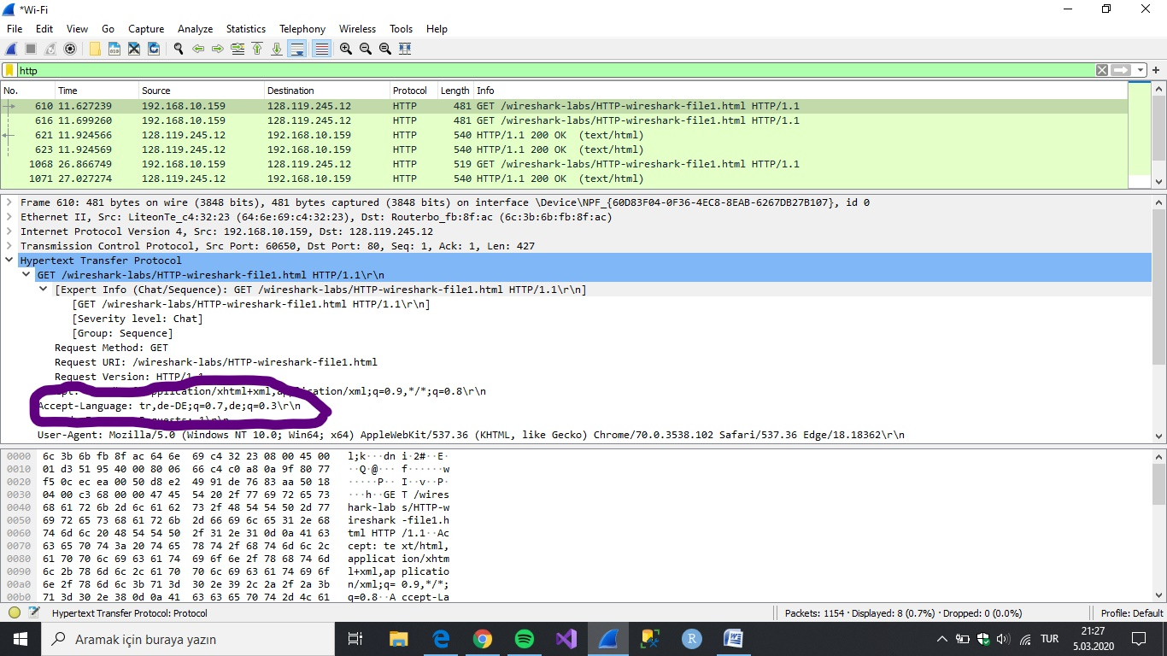

Question 3 - )The IP address of my computer is 192.168.10.159

The IP address of server is 128.119.245.12

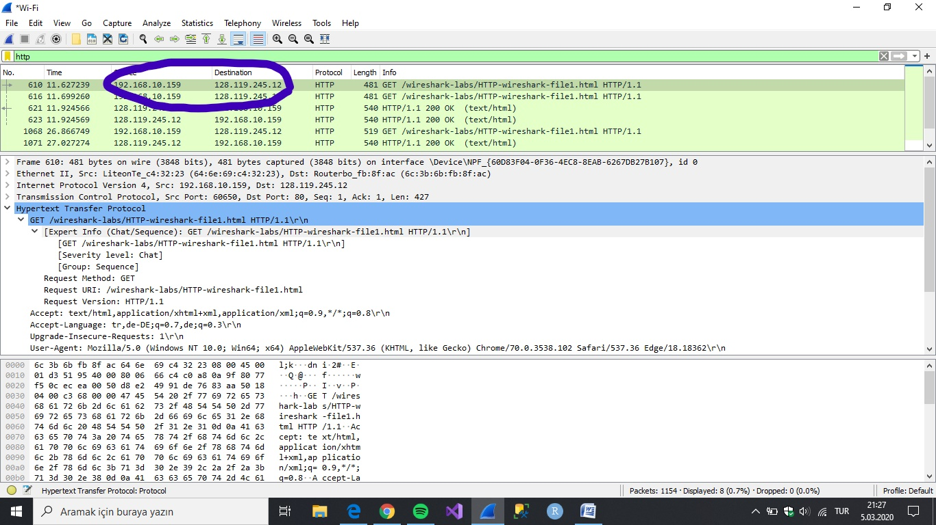

Question 4 - ) The status code returned was 200 OK.

Status code information is listed in the HTTP OK message.

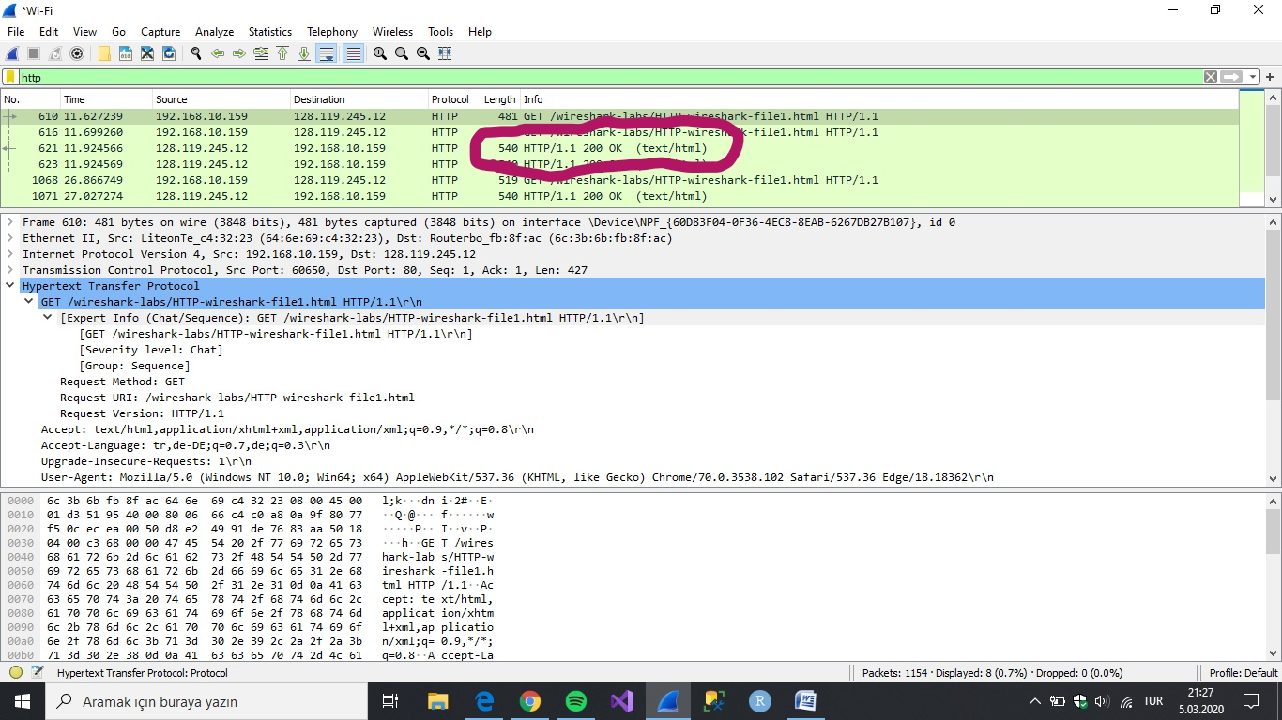

Question 5 - )Thu , 05 Mar 2020

Last modified information is listed in the item ‘Last-Modified’ in the HTTP OK message.

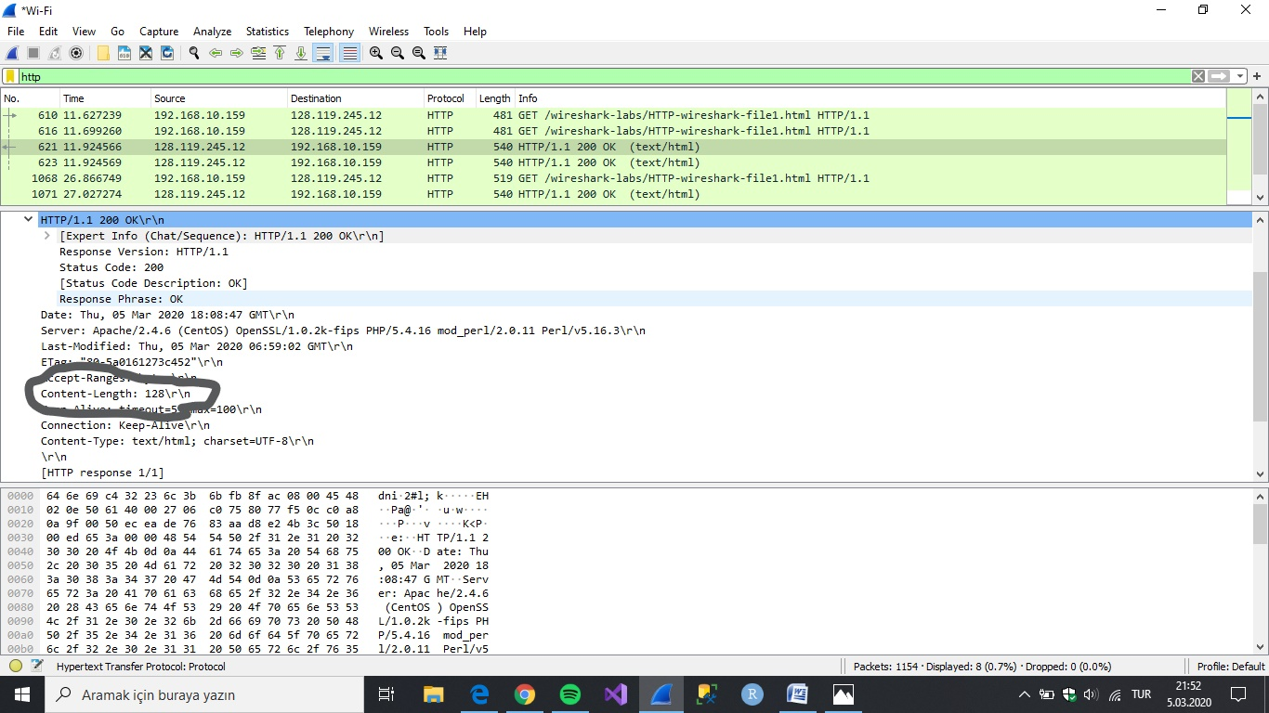

Question 6 - )Content Length = 128

Content length information is listed in the item ‘Content-Length’ in the HTTP OK message.

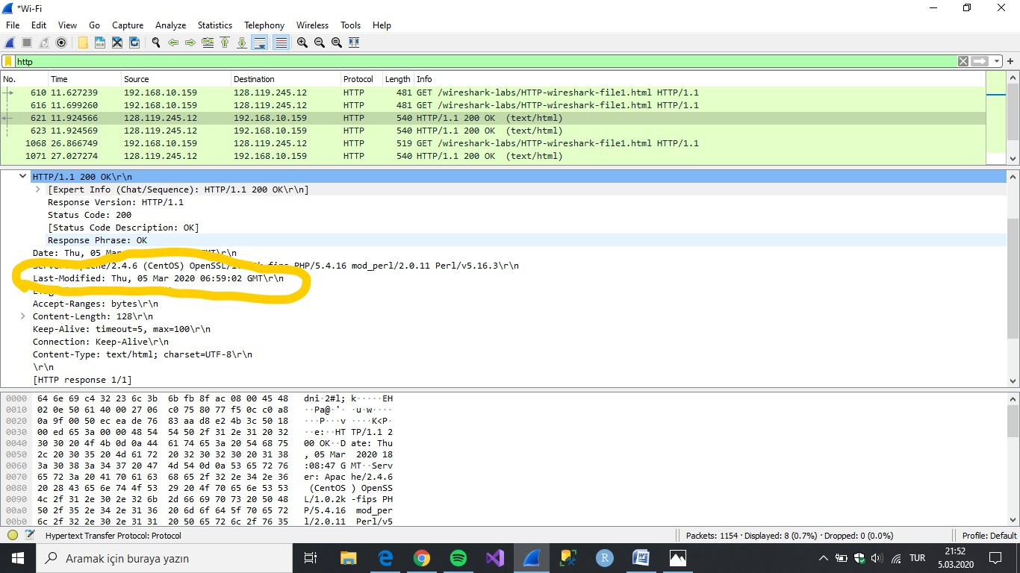

Question 7 - ) There is not IF-MODIFIED-SINCE line in the GET message.

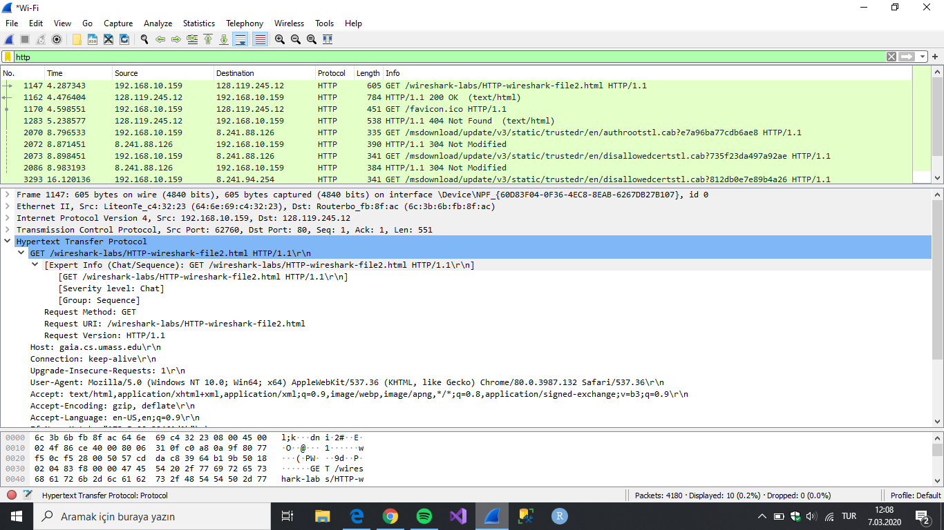

Question 8 - )

Yes , The server’s response can be seen under Line-based text data field.

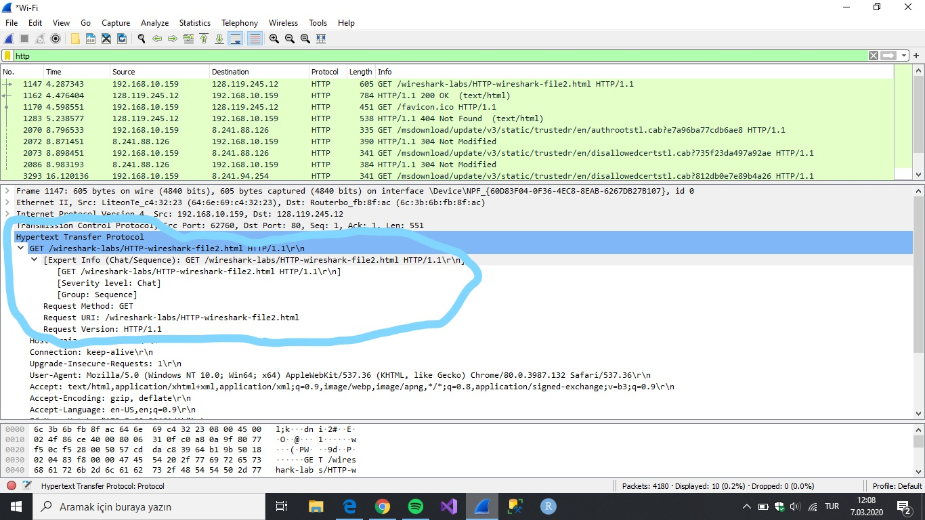

Question 9 - )Yes , in the second http message an IF-MODIFIED-SINCE line is included.

This message contains the date and time.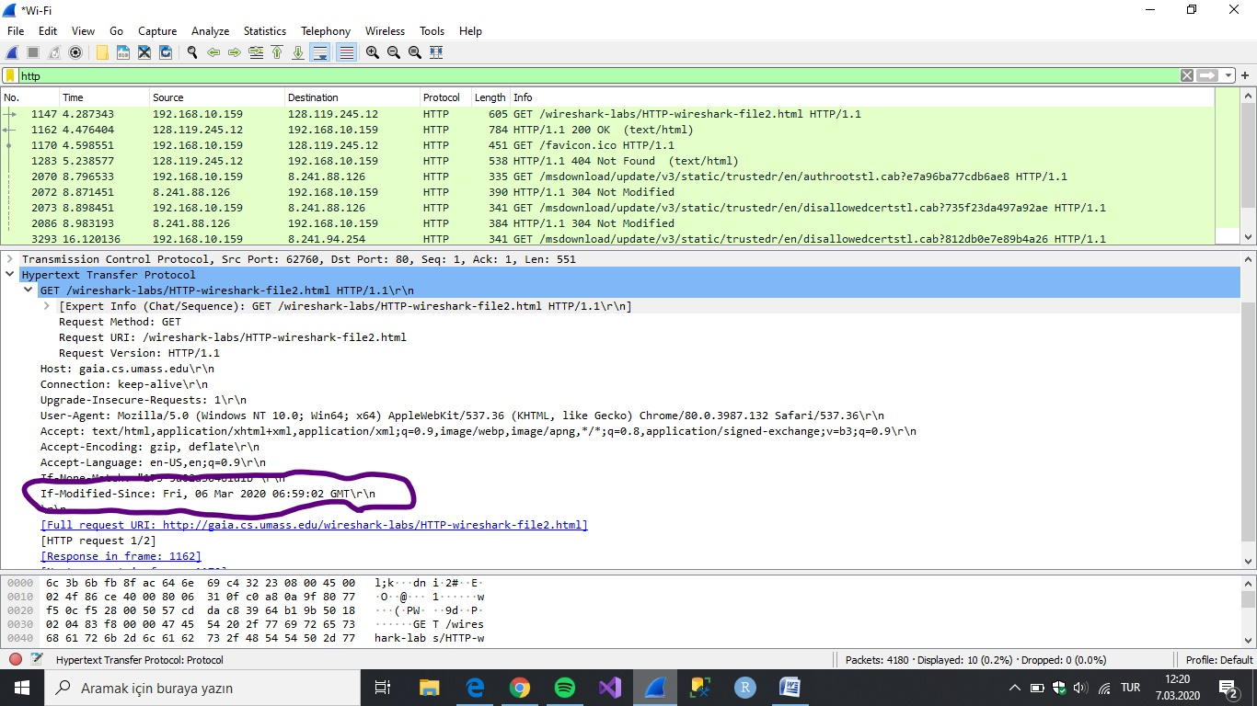

Question 10 - )The HTTP status is ‘304 :Not Modified’

The server did not return the contents of the file as the browser loads the file contents from the cache.

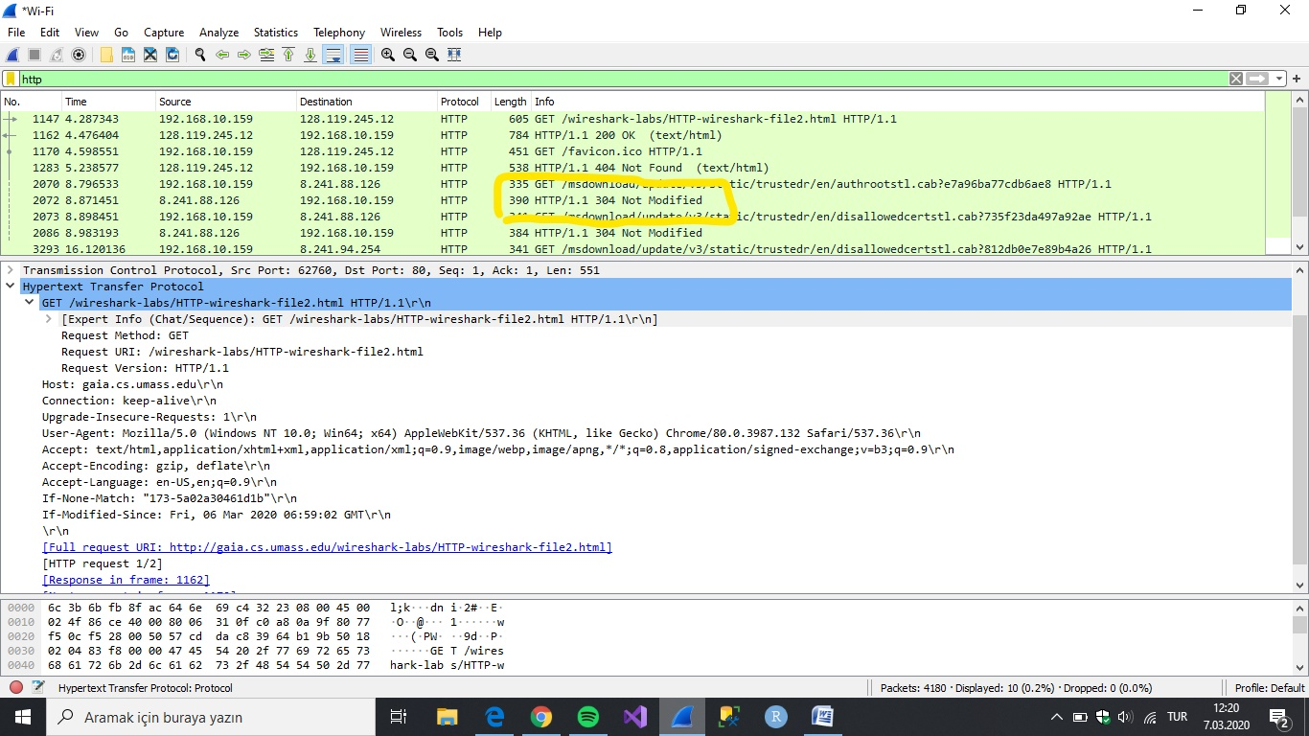

Question 11- ) My browser only set 1 http GET request to the server.

The packet contained the GET message was packet number 219.

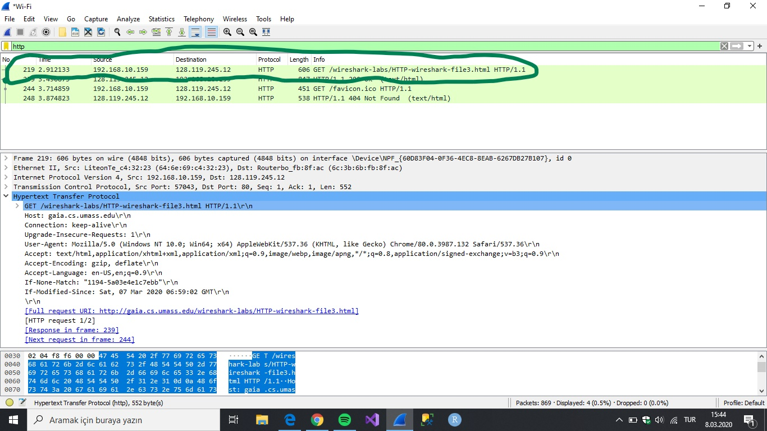

Question 12 - ) The packet that contains the status code and phrase which the server sent in response to the GET message was packet number 244.

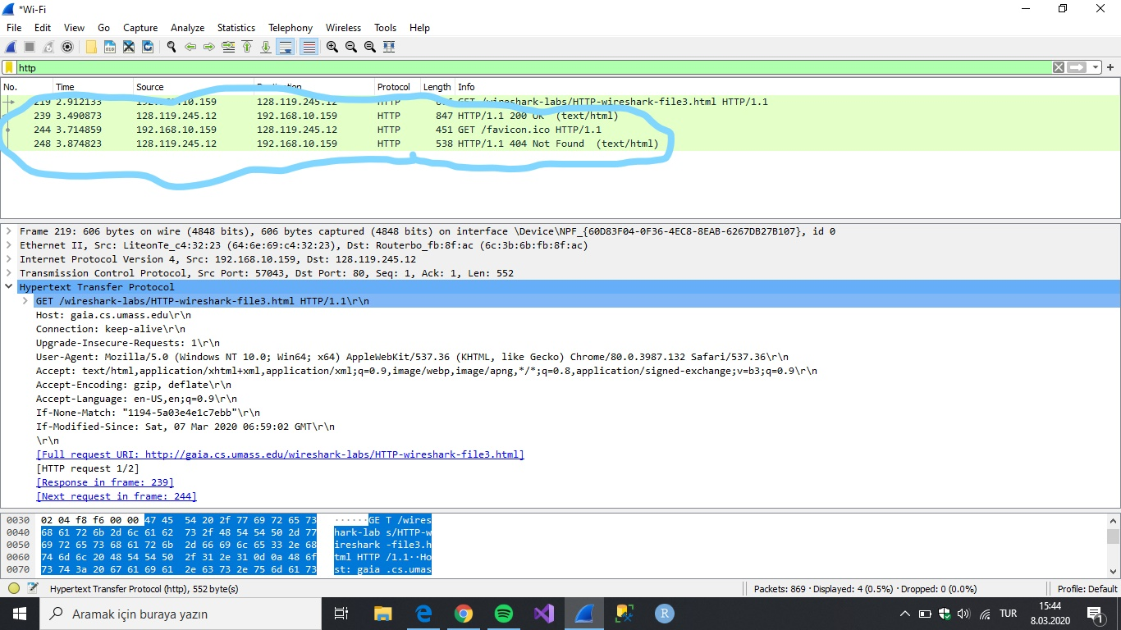

Question 13 - ) The code and phrase in the response was 200 OK .

Question 14 - )The data was not sent in TCP segment in the browser.

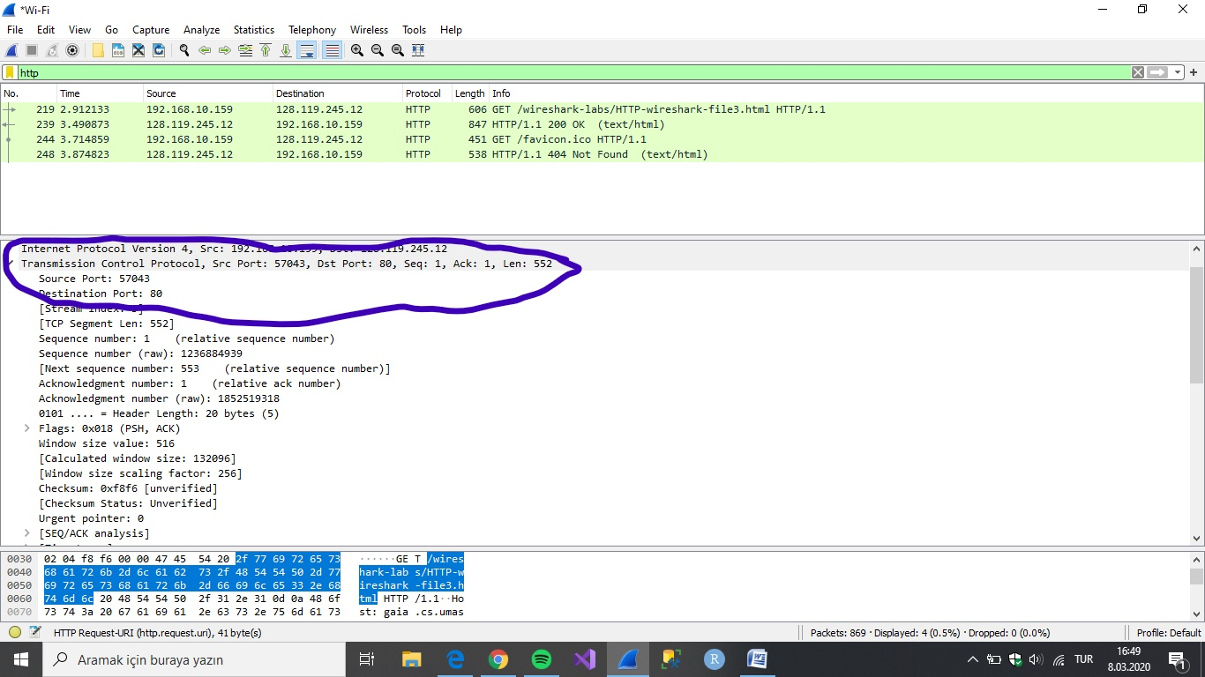

Question 15 - ) My browser sent 1 http GET message request.

Inıtial Page address : 128.119.245.12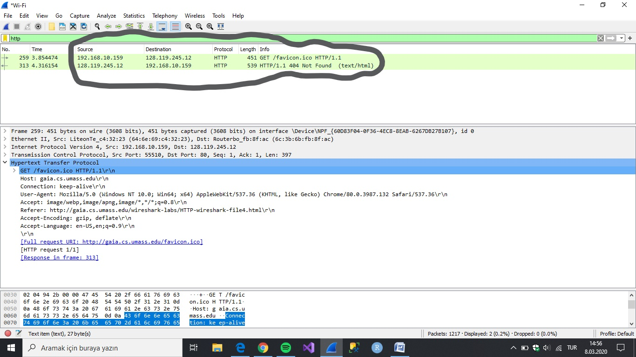

Question 16 - )The browser downloaded the two images serially.

They have been requested then would have returned in the same time period.In this case ,

The second images was only requested after the first image came back.But the browser did not answer us. 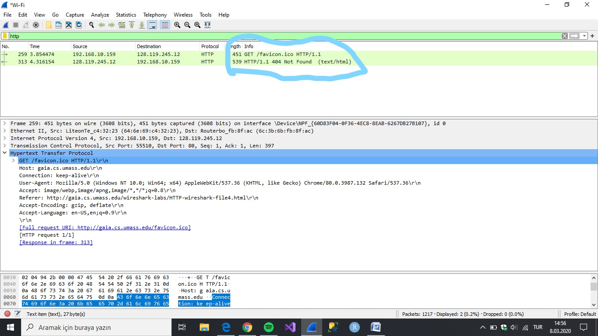

Question 17 - )The servers intial response was “401 Authentication Required”.

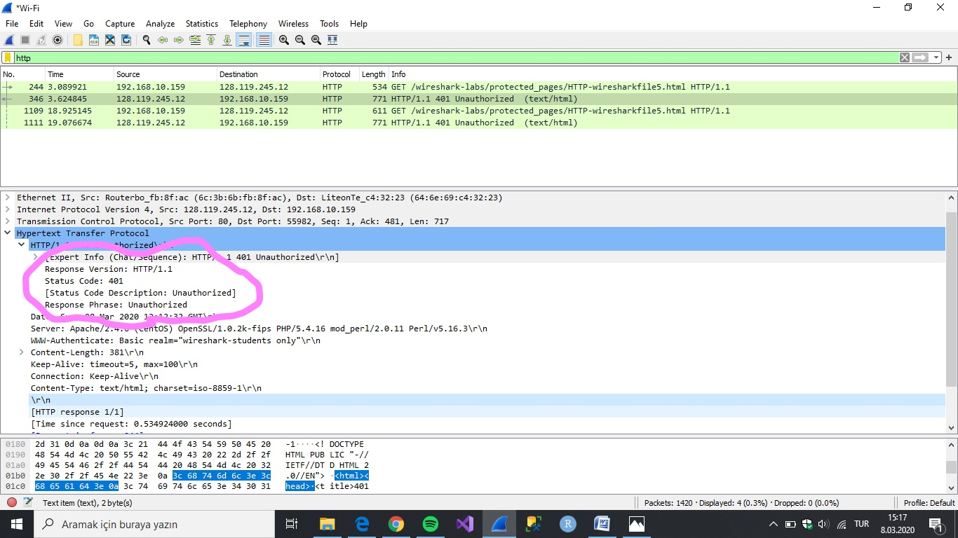

Question 18 - )The new field is now included the authorization field.

This is included because we sent the server a username and passsword along with our request

Stating that we were authorized to receive the page.

